**IP EXPERIMENT 9 - Installation of React DOM library**

Step 1 : Install Node Js

ss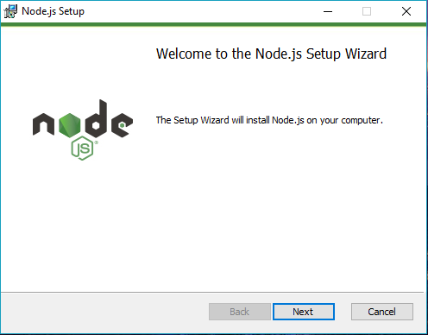

Step 2 : Install node package manager (npm) :

Install and check the version

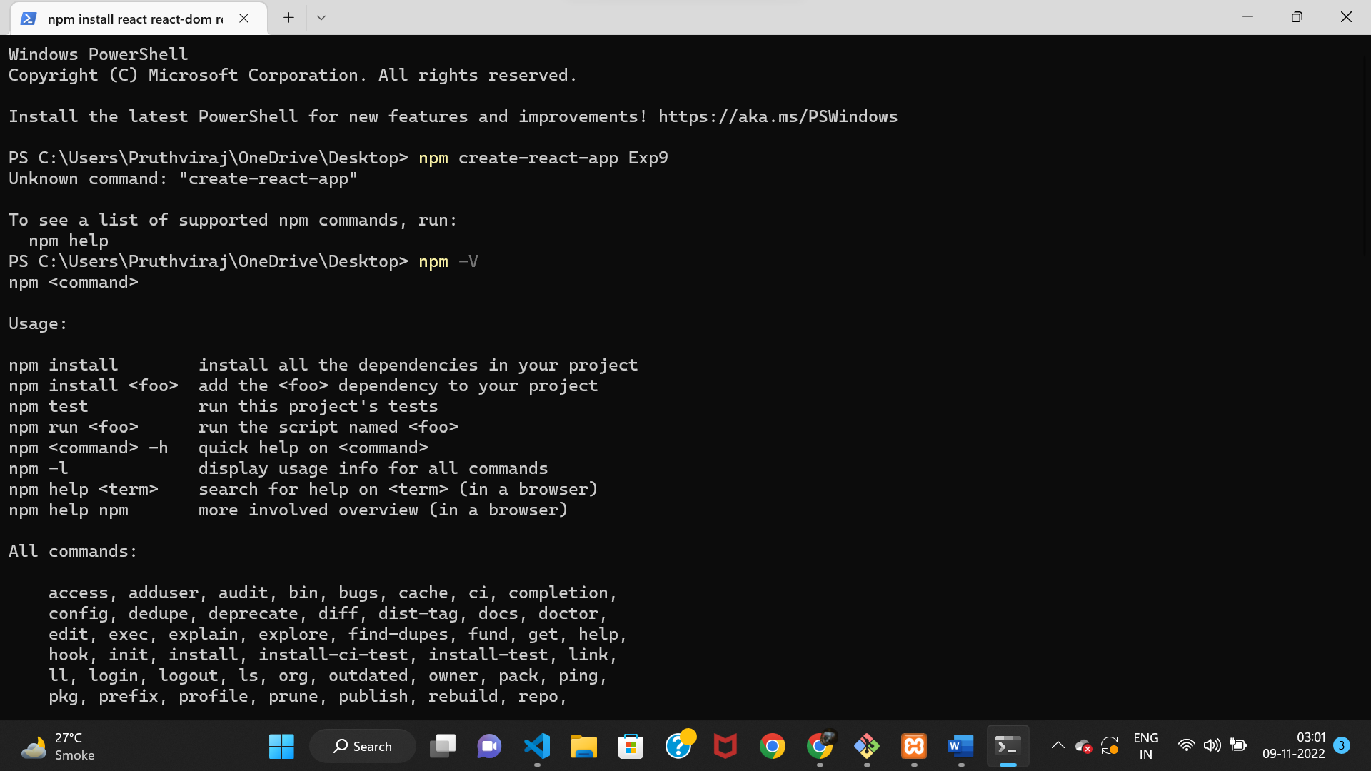

Step 3 : Run command npx create-react-app name-of-app

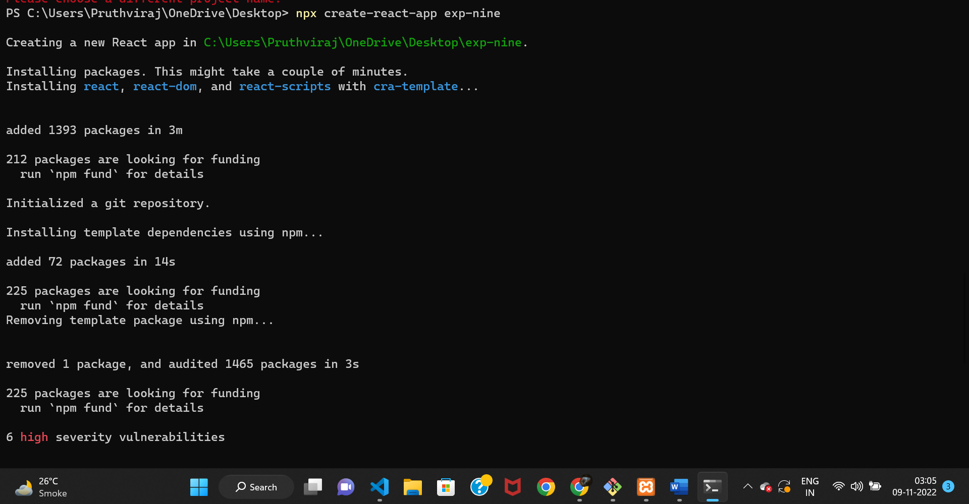

Step 4 (Final) : Run /Start the app by going to the respective folder and running the command as “npm start”

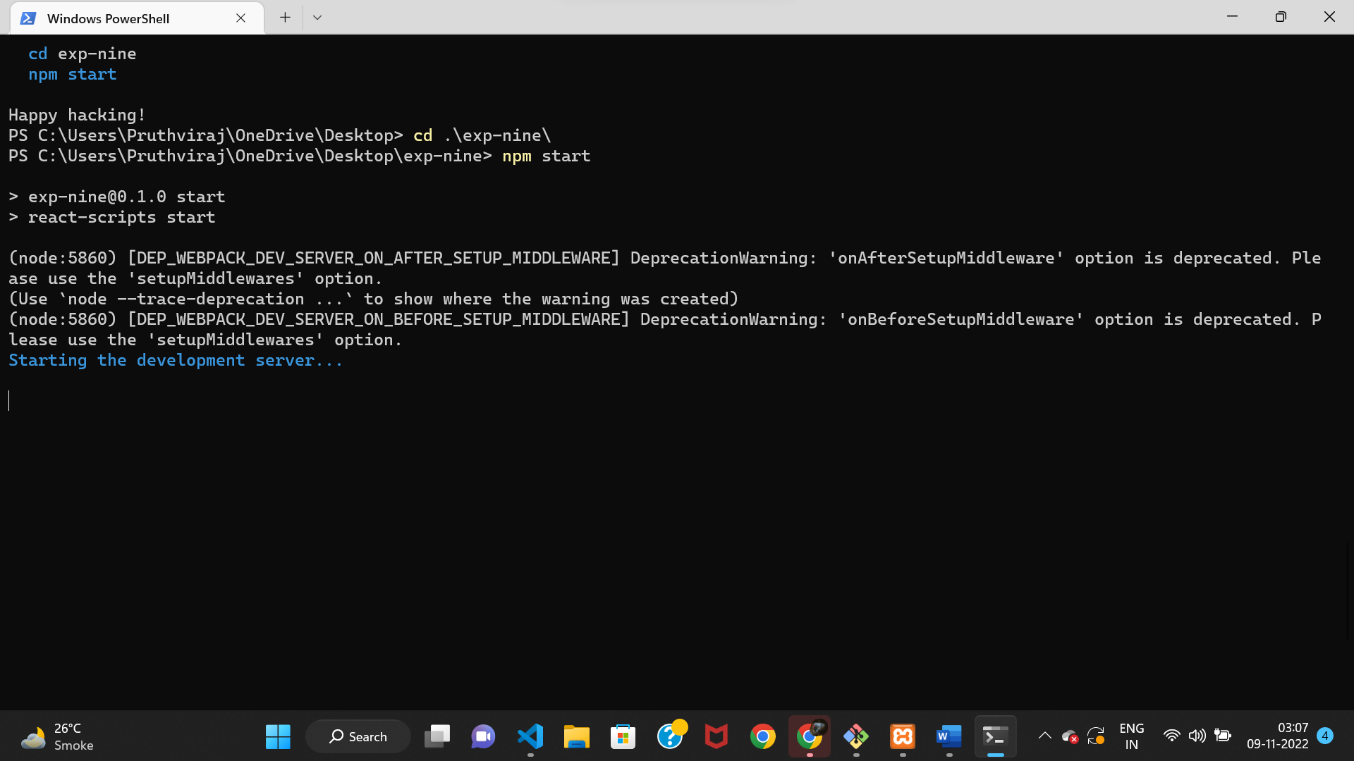

THE APP IS RUNNING NOW !!!!

